 | Including | Available from
Canvases | 18x24”  10x12” | Hobbycraft
2 packs of Flat Brushes – similar  Any other favourite Brushes | 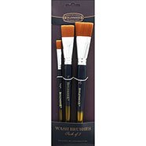 | The Works £2
1 medium dagger brush | Pro Arte Masterstroke Series 65I Dagger Striper. Artists Single Brushes Medium size | available on ebay
2x Cheap 1” natural bristle decorator brushes (not nylon) |  | The Range or B&Q
2 x Tear off palettes | 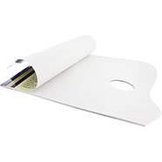 | The Works £2
Boiled Linseed Oil OR |  | Wilkies or B&Q
Liquin medium |  | The Works or The Range
Various diamond and pear shape palette knives
Oil Paints for Stormy seascapes  Should include:  Burnt umber  Prussian Blue  Cadmium Red  Viridian  Cerulean blue  Titanium White  (Alkyd white & Liquin will dry the painting quicker)  Yellow Ochre  Cadmium yellow light | 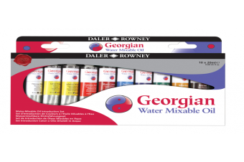  Oil or water based paints.  Alkyd Oils will speed up drying time | Hobbycraft
Pkt of Hake Brushes |  | The Works £3
Palette knives | Various shapes and sizes.

